**Install Ballerina 0.990.0**

1. Go to <https://ballerina.io>
2. Click on the Download box:  
   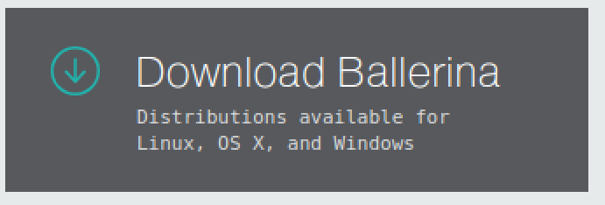
3. Click on the Linux Box:  
   
4. When the download has finished, install the .deb:

sudo dpkg -i ~/Downloads/ ballerina-linux-installer-x64-0.990.0.deb

1. Validate that you have it installed properly:

$ ballerina version

Ballerina 0.990.0

1. Unfortunately we have an out-of-date vscode plugin, and some associated config that needs removing first.
2. If not, then:  
   1. Open vscode
   2. Hit Ctrl+, to edit settings
   3. Type ballerina into the search bar
   4. Delete the contents of the Ballerina Home box  
      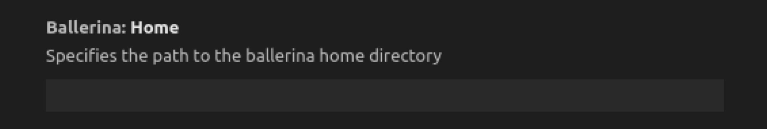
   5. Ignore the message:  
        
      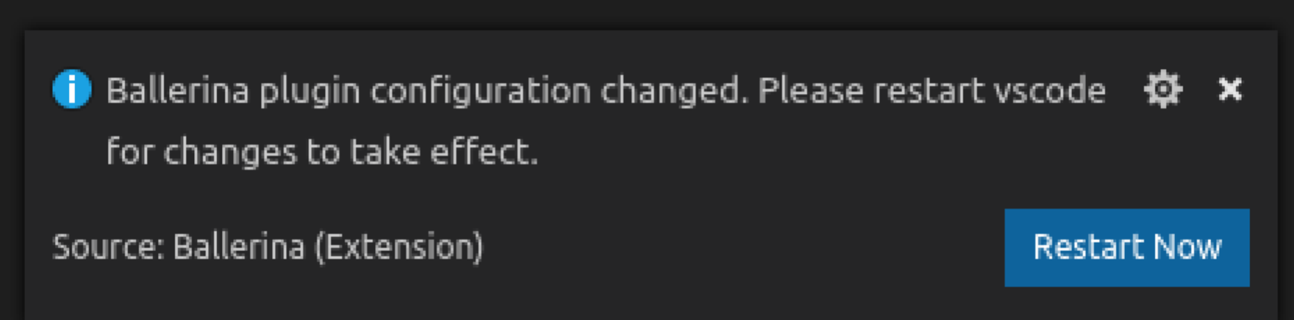
   6. Close the settings window and then exit vscode
   7. On the command line do the following:  
      rm -rf ~/.vscode/extensions/ballerina.ballerina-0.983.1/
   8. Start vscode again
   9. Command Palette -> Install Extensions
   10. Search extensions for Ballerina  
       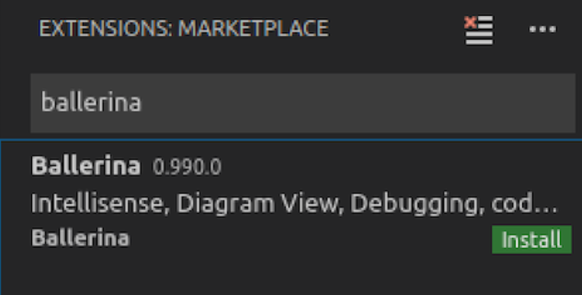
   11. Click Install
   12. Wait a bit….
   13. Click **Reload to Activate**
   14. That’s all!